**Power BI Project**

on

**Healthcare**

**Case Study on Advancing Healthcare Analysis through Data Insights**



**Summary**

**Company**: HealthStat Solutions

**Datasets**: 'Patient Medical Records' and 'Hospital Treatment Details'

* **Patient Medical Records** dataset contains detailed information on patients, including their age, gender, blood type, diagnosis, treatments, admission and discharge dates, and total bills.
* **Hospital Treatment Details** dataset provides insights into the hospitals treating these patients, including the treating doctor, room number, daily costs, treatment types, and recovery ratings

The task is to analyze these datasets, uncovering trends and insights that could improve patient outcomes and optimize hospital operations.

**Objective:**

* Visualize interplay between patient demographics.
* Treatment outcomes.
* Cost implications of various medical procedures.
* Overall hospital performance metrics.

**Part 1: Data Cleaning, Modeling, and DAX in Power BI**

1. Data Importing and Initial Examination
2. Merging and Relating Datasets
3. Cleaning: Handling Missing and Irrelevant Data
4. Data Type Conversion
5. Categorizing Age Groups

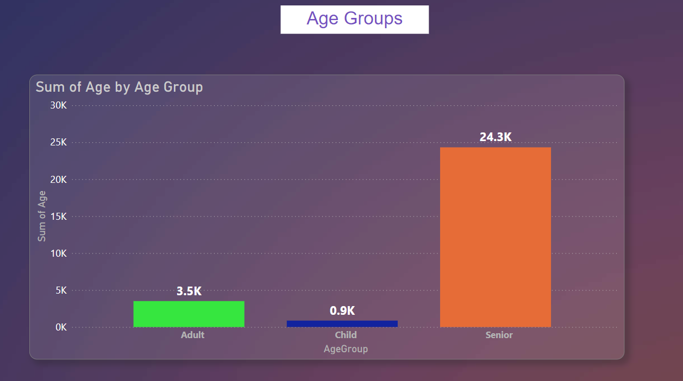

1. Analysis of Treatment Costs

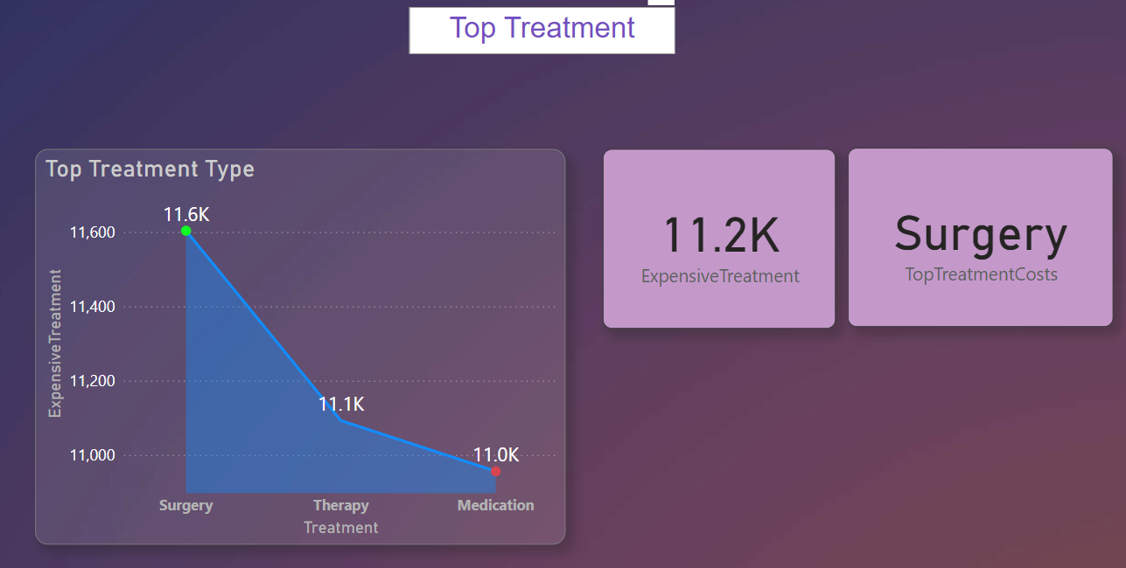

1. Gender Distribution in Diagnosis

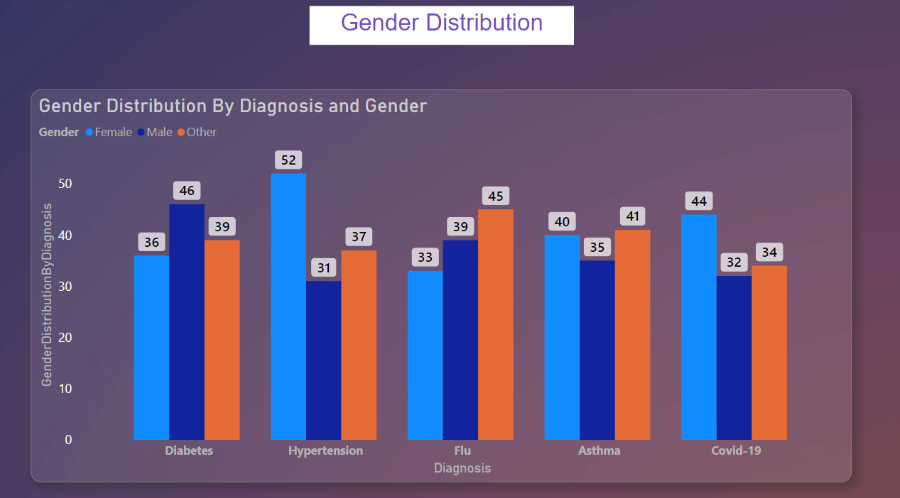

1. Blood Type Analysis

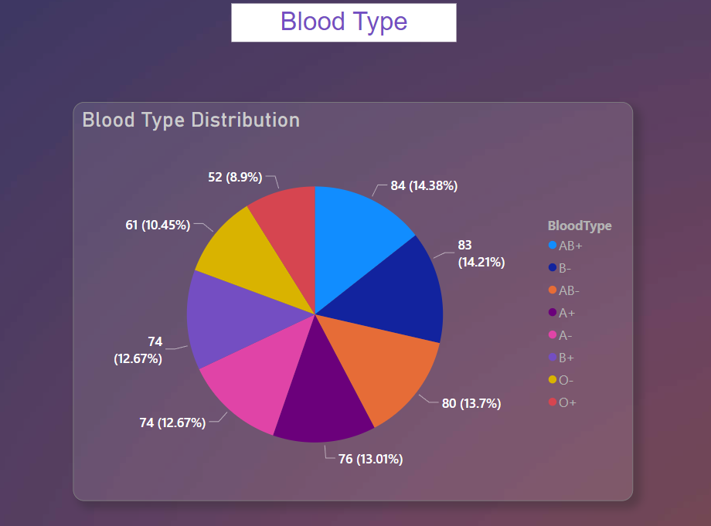

1. Recovery Rating Analysis

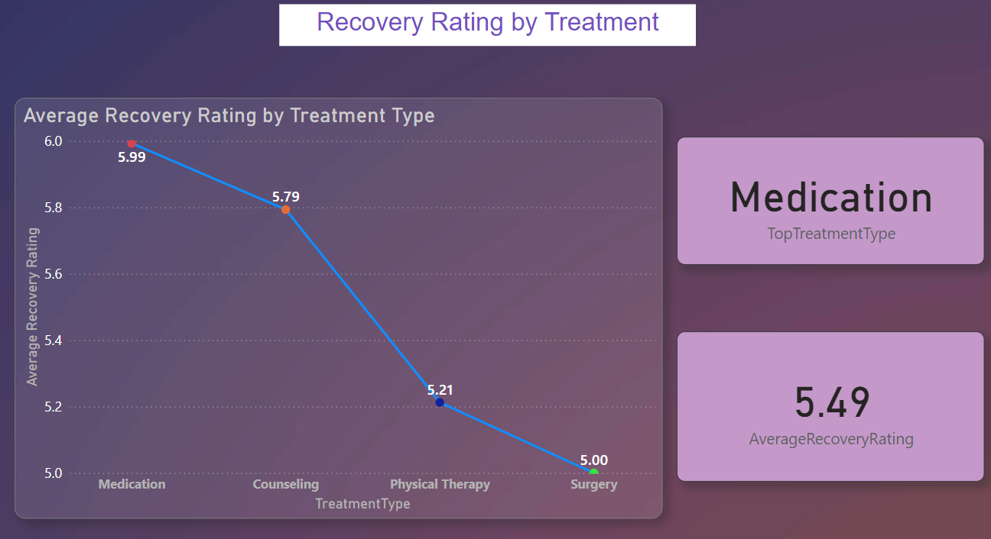

1. Hospital Utilization Analysis

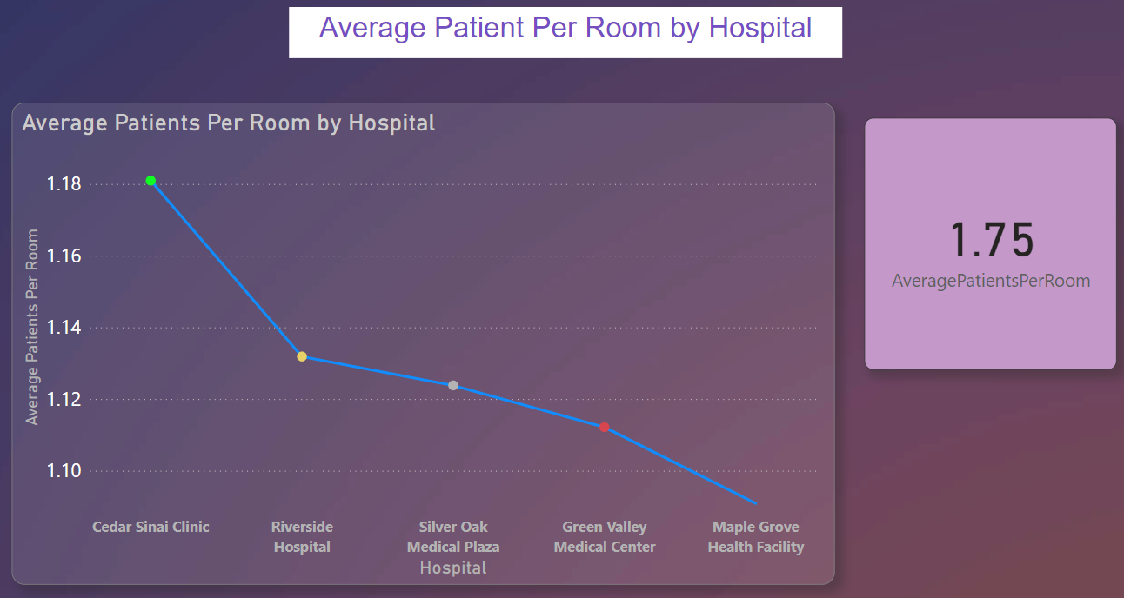

1. Doctor's Patient Load

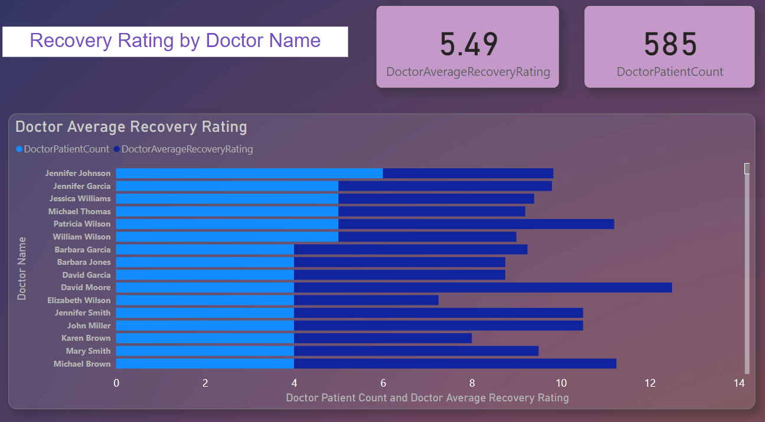

1. Treatment Effectiveness

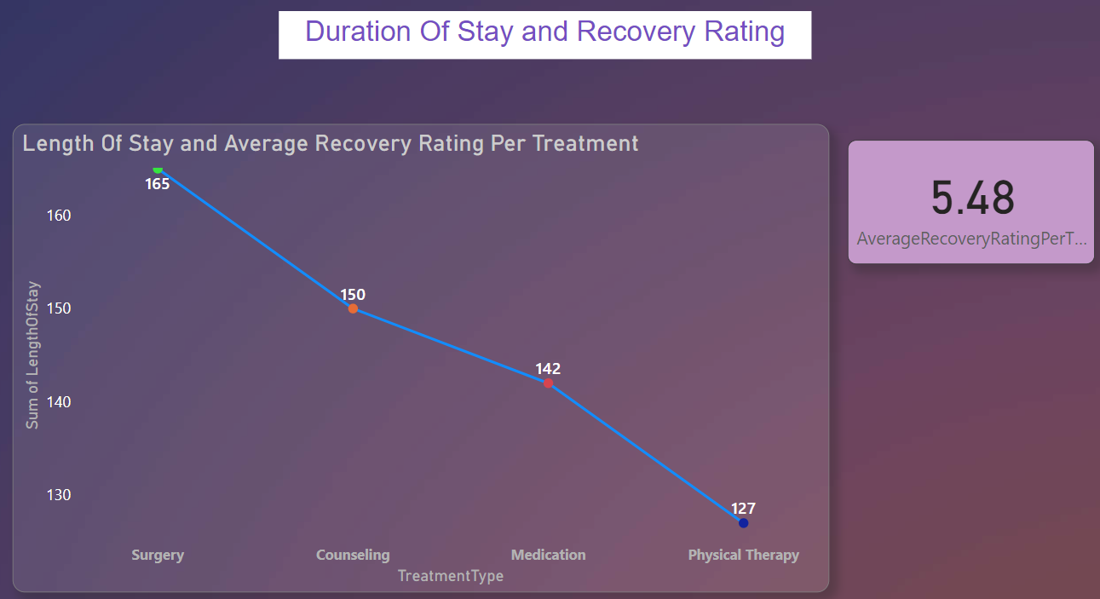

1. Cost Analysis by Hospital

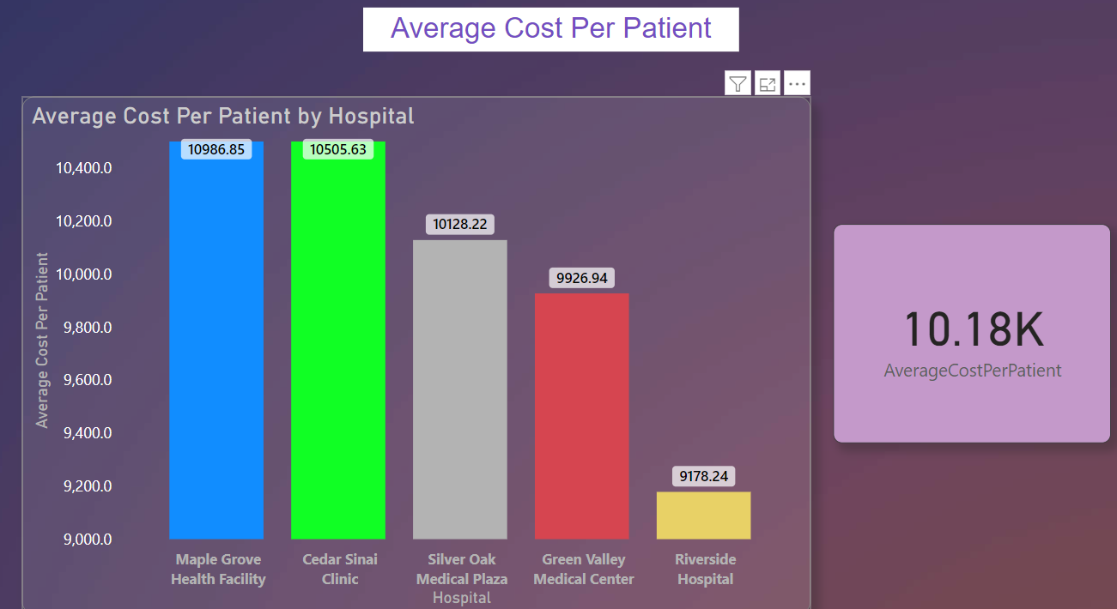

1. Patient Admission Trends Over Time

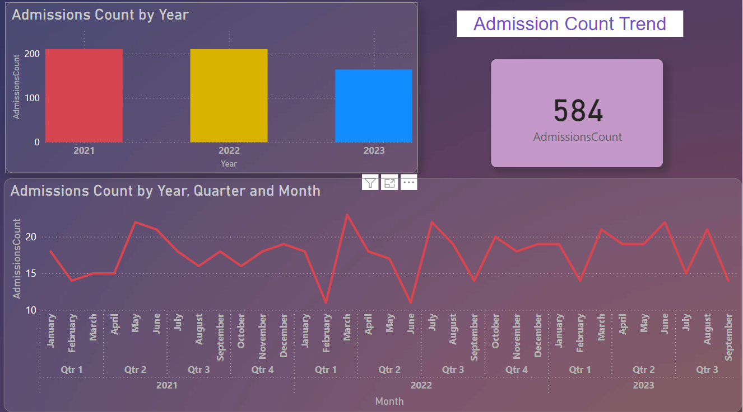

1. Correlation Between Age and Recovery

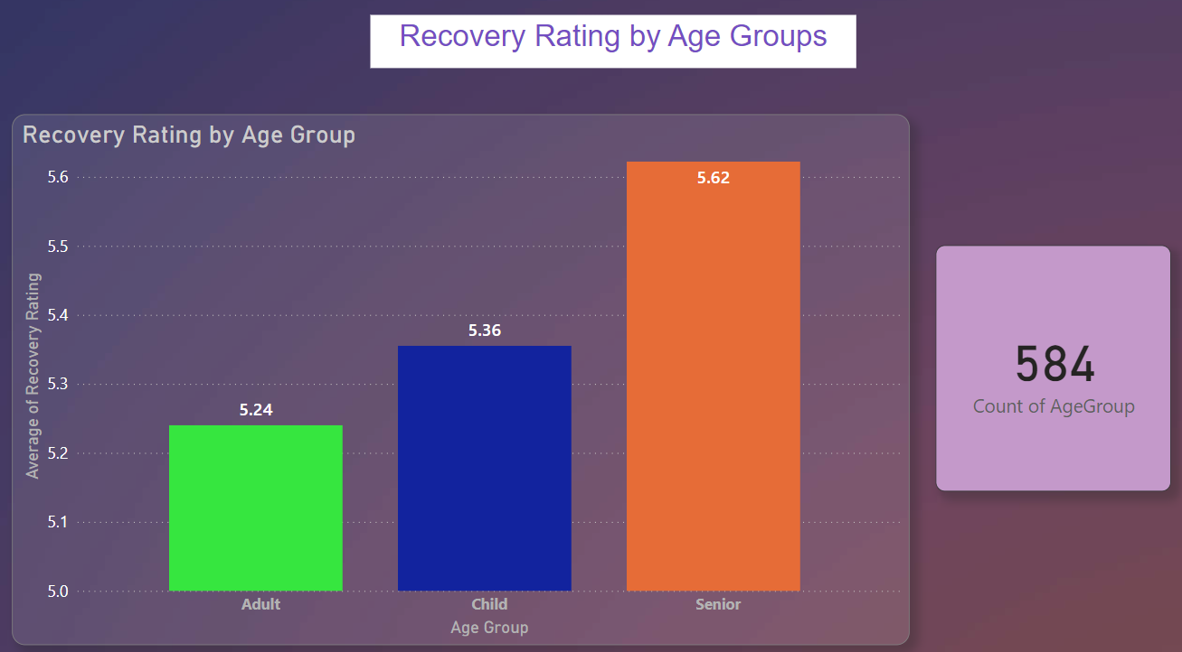

1. Analyzing Room Efficiency

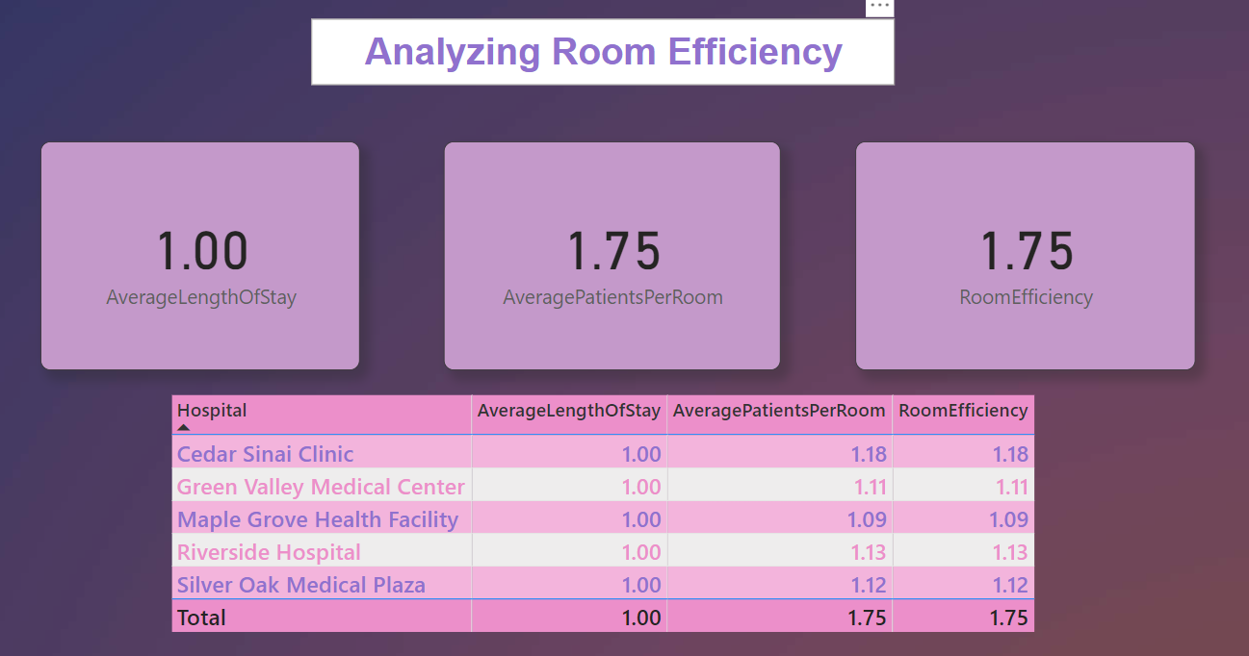

1. Impact of Doctor on Recovery

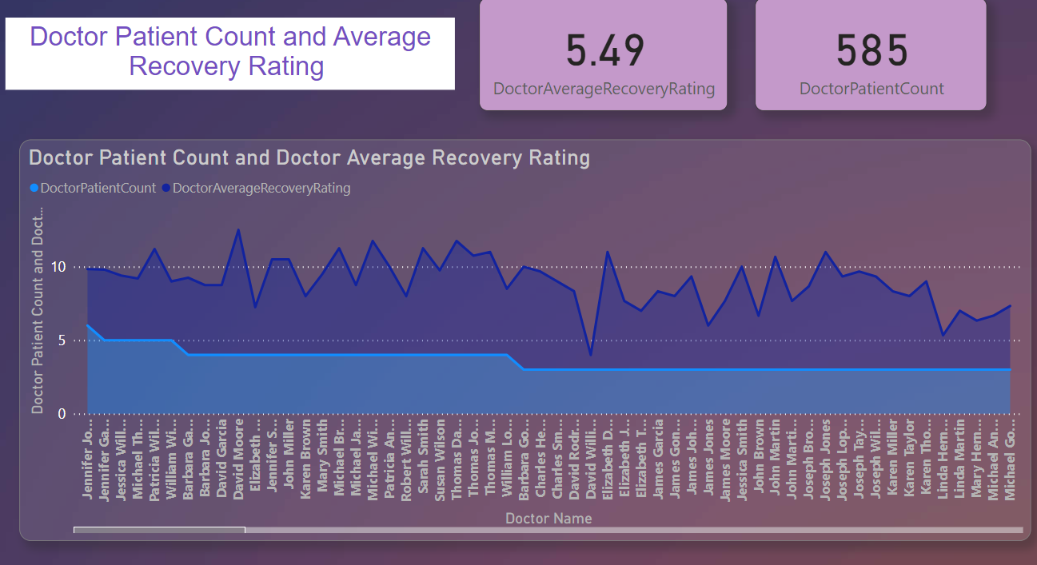

1. Advanced DAX: Length of Stay and Cost Correlation
2. Recovery Trends by Gender and Age Group

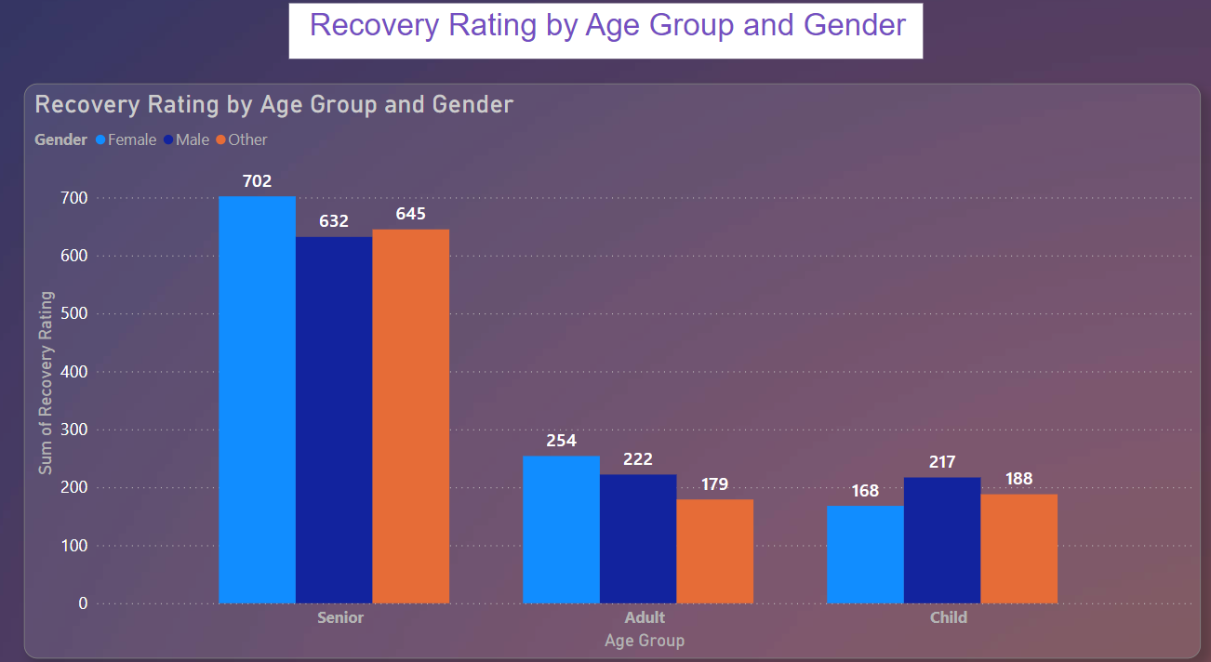

1. Hospital Performance Analysis

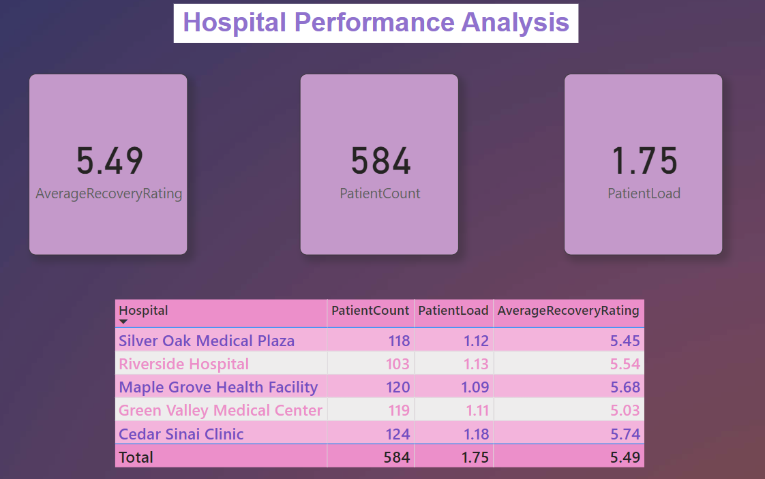

1. Extracting Key Information

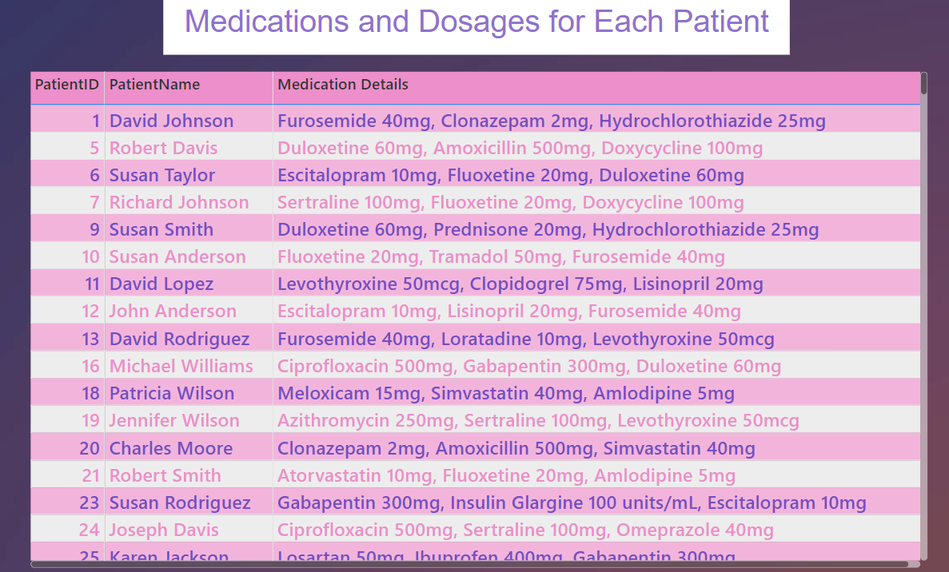

1. Complex DAX: Predictive Modeling for Recovery Rating
2. Data Modeling: Cohort Analysis Based on Admission Date
3. Advanced Data Transformation: Predicting Future Hospital Capacity Needs

**THANK YOU**